Chapter 11, Problem 85.

A regular household system of a single-phase three-wire allows the operation of both 120-V and 240-V, 60-Hz appliances. The household circuit is modeled as shown in Fig. 11.96. Calculate: (a) the currents I₁, I₂, and I_{n}, (b) the total complex power supplied, (c) the overall power factor of the circuit.

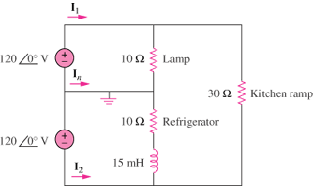

Figure 11.96
For Prob. 11.85.

